Experiment 5: Mark Sheet Processing System
Aim
To create a simple cloud-based Mark Sheet Processing System using a cloud service provider to demonstrate SaaS.
Algorithm
1. Open Zoho Creator and create a new application.
2. Create a form named Mark Sheet Processing System.
3. Add fields such as Student Name, Register Number, and Subject Names.
4. Add fields to enter marks obtained in each subject.
5. Calculate the total marks and average marks.
6. Calculate the percentage based on the total maximum marks.
7. Add fields for Rank and Overall Performance.
8. Save the form and publish the application.
9. Enter student marks and view the processed results.
Implementation
Input
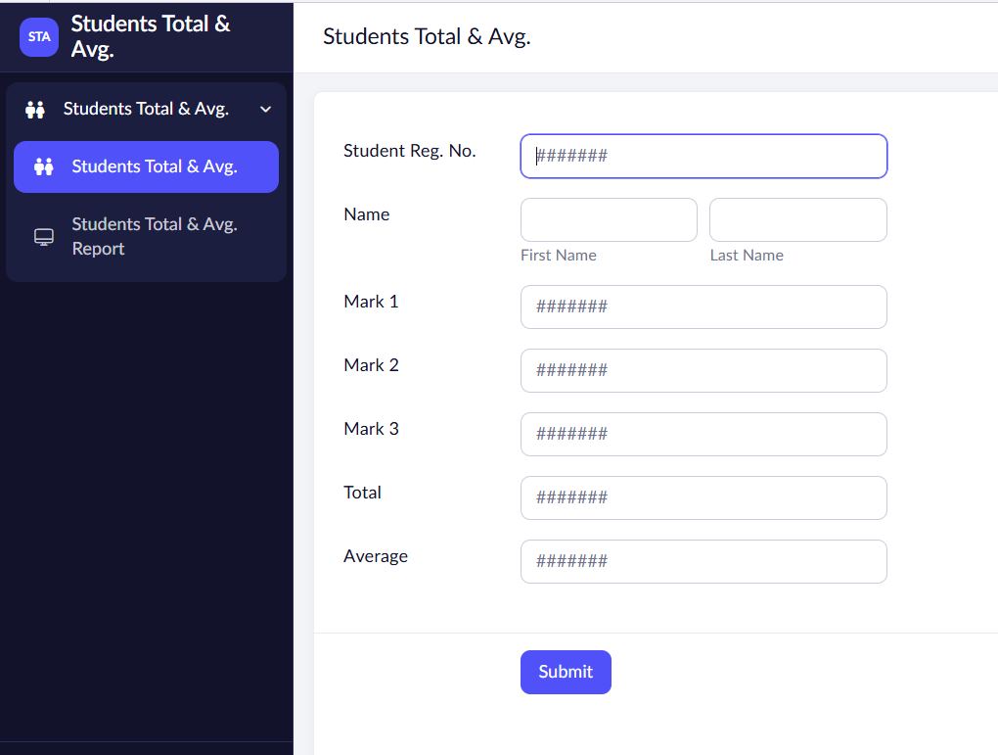

Output
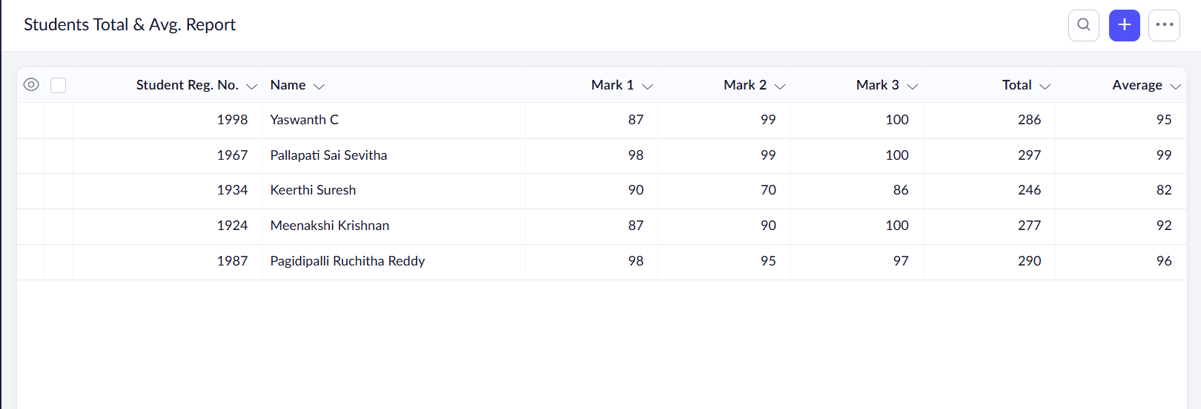

Result
Thus, a cloud-based Mark Sheet Processing System was created successfully to manage student marks and process academic results.

